RESUME

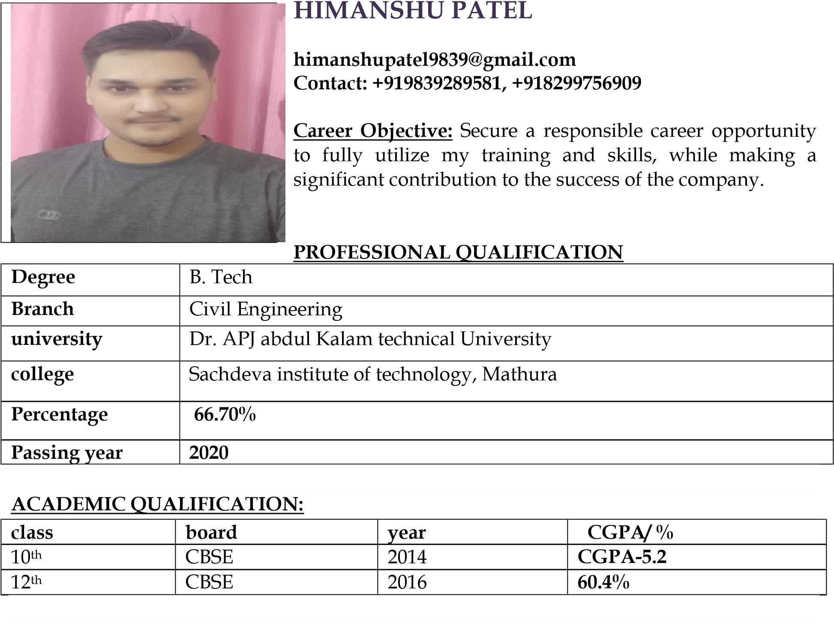

**Professional Experience: (Oct’2020 to Oct’2021)**

* Worked as a trainee engineer and field engineer in Building construction work at Tripurari Enterprises, Lucknow.

**PROJECT:**

* Advance study of safety at public places and roads.

**INDUSTRIAL TRAINING:**

* One month summer training at PWD, Raebareli.

**INDUSTRIAL VISIT:**

* Visit in Heidelberg cement (Mysem cement), Jhansi, Madhya Pradesh.

**SOFTWARE SKILLS**:

* AutoCAD
* Revit Architecture
* Tally.ERP9
* Microsoft office
* Typing skills

**LINGUISTIC PROFICIENCY:**

* Hindi
* English

**STRENGTHS AND KEY SKILSS:**

* Positive attitude and strong work ethic.
* Leadership and team work spirit.
* Motivating people.
* Good communication and people oriented.
* Flexibility.

**ACHEIVEMENTS:**

* Winner of PWD Cricket tournament in 2015, lead as Captain.
* Winner of prize competition held by city group of colleges, Lucknow.
* Certificate by participating school culture programs and annual function program.

.

**PERSONAL INFORMATION:**

* DOB: Aug 10th, 1998
* Gender: Male
* Father’s name: Mr. Tripurari Singh
* Nationality: Indian
* Communication address: Gali no.3, Pawanpuri colony,ring road,devikhera, telibagh, Lucknow.

**DECLARATION:** I hereby declare that the details mentioned above in my resume are correct to the best of my knowledge and belief. I bear the responsibility of any error or mistake in the data, if occur in the future.

**(HIMANSHU PATEL)**